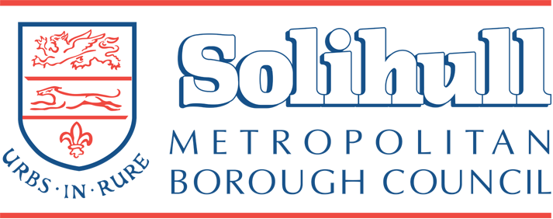

Celebration Tree Sponsorship Scheme
2024 - 2025
Solihull Metropolitan Borough Council provides a scheme for residents and non-residents to sponsor a celebration tree(s) in several Parks and Open Spaces throughout the Borough.
The terms and conditions are set out below.
- The charge for each tree is £495 exc. VAT, we will supply a select standard containerised tree at an approximate height of 2 – 3 metres this includes planting, stakes, compost, ties.

- The Council will provide you with a choice of tree species, this is to ensure that the right tree is chosen for the selected location.

- The tree will be maintained from planting until established which will normally be up to three years. We will typically water new trees regularly from April to August each year for the first 3 years after they have been planted.

- Solihull Council plant trees in the late autumn and winter period, this gives trees the best chance of establishing. We will confirm the approximate time of planting when your application is confirmed.

- Trees may fail for several reasons, including vandalism and disease. We will do our best to replace the tree once during the first three years after it has been planted.

- Please be aware that no dedication plaques can be displayed on celebration trees.

- If unforeseen circumstances require it, the council reserves the right to move or remove any tree. We would plant a replacement tree in an appropriate location.

- The tree will always remain the property and responsibility of Solihull Council.

- Applications for celebration trees will be taken and processed from January to June.

- The Council has no commitment to accept any application for a celebration tree.

- Cremation ashes can have a serious impact upon the local environment. Some of our locations have plant species which provide habitat for local wildlife and soil ecology that are very sensitive to human ashes which contain a lot of phosphate and calcium which may kill the local habitat. Ashes scattered directly into a tree planting hole can harm the roots of the tree and affect its health. Therefore, we do not allow ashes to be scattered in any of our Parks, Open Spaces or Woodland.

- We do not allow members of the public to buy and plant their own trees on publicly owned sites.

Once your application has been accepted you will be invoiced for the tree(s), the invoice will show the amount you will need to pay and the details of the service you are being invoiced for, including information how to pay.

